RISC-V Product Development Hackathon:Top of Form

**Stage 1-Product Idea Submission Form**

1. **SOIL MOISTURE BASED AUTOMATIC IRRIGATION SYSTEM**

*Theme: Agriculture*

1. **What does your product do?**

* Detect and Run

1. **What all interfaces of the board will used in the product ?**

* IIC/SPI pins and GPIO pins for Soil Moisture Sensors
* IIC/SPI pins and GPIO pins for 5V Relay module

1. **Does the product utilise sensors?**

* YES

1. **If "Yes" for above question, then list your sensors here  
    -** Soil Moisture Sensor
2. **Draw a Block diagram of the product.**

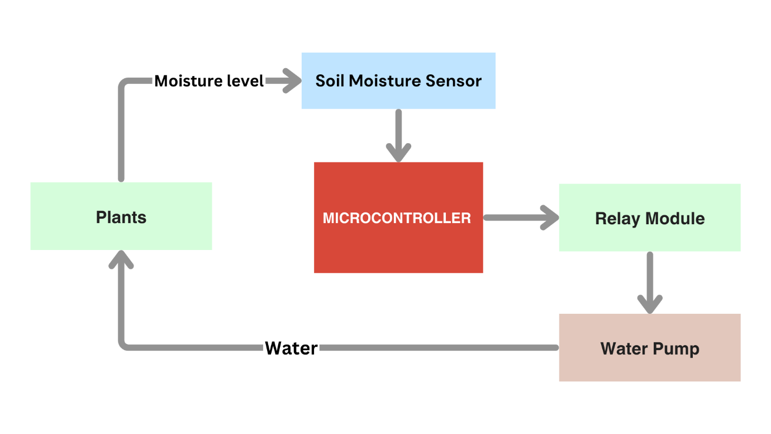

1. **Upload the Algorithm flowchart of the product.**

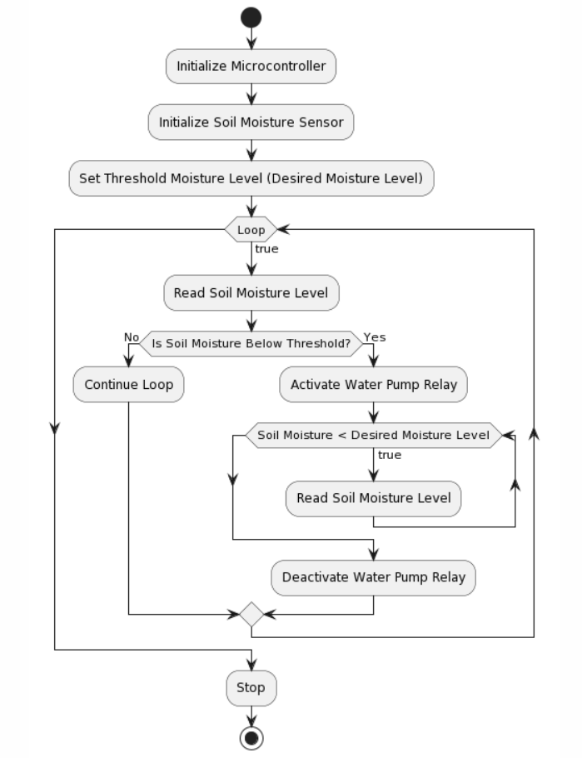

1. **Explain the algorithm of the product in bullet points.**

* Set up the Microcontroller
* Initialize the Soil Moisture Sensor
* Set a threshold moisture level in the microcontroller
* Read soil moisture level
* If soil moisture is the below threshold level, turn on the water pump.
* Turn off water pump when the soil moisture level reaches the threshold level.
* Repeat the process whenever the soil moisture level goes less than the soil moisture threshold value.

1. **Draw a Rough sketch of the final product.**

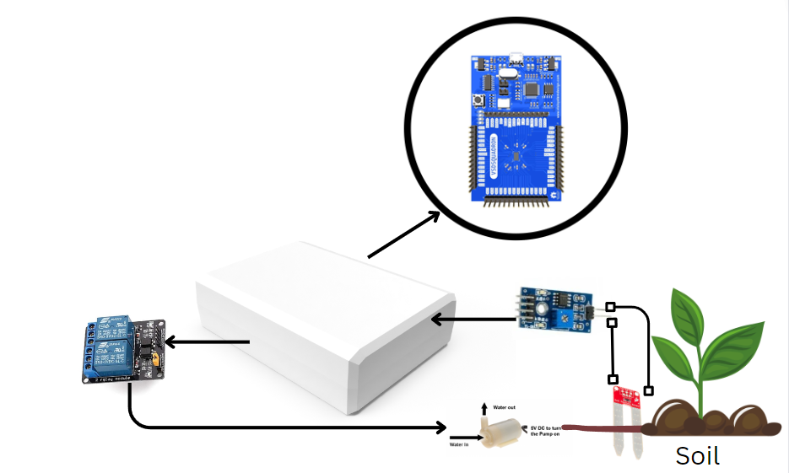

1. **Upload the rough sketch of the Internal product (With all connection of components with the board and the product.).**

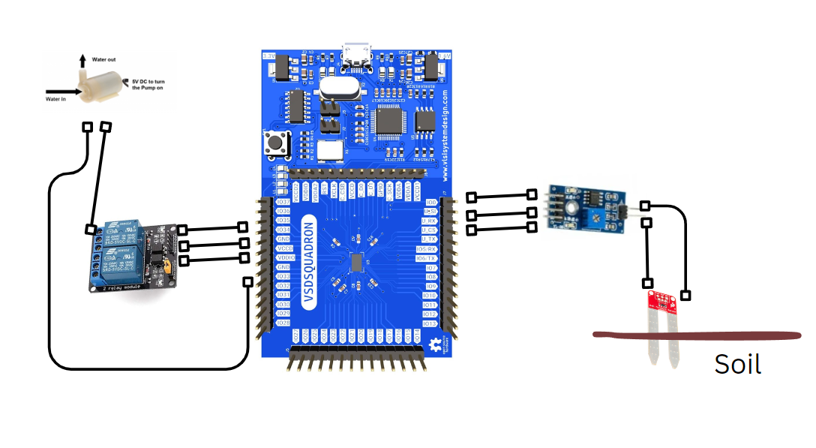

1. **BoM list (excluding the board) with cost.**

|  |  |  |  |
| --- | --- | --- | --- |
| **Component name** | **Quantity Required** | **Unit price** | **Total Price**  **(Unit price*Quantity)** |
| Soil Moisture Sensor Module | 1 | Rs.100 | Rs.100 |
| 5v Relay Module | 1 | Rs.80 | Rs.80 |
| 6v Mini water pump with pipe | 1 | Rs.150 | Rs.150 |
| 9v Battery | 1 | Rs.25 | Rs.25 |

1. **Team details**

|  |  |  |  |  |  |  |  |
| --- | --- | --- | --- | --- | --- | --- | --- |
| **Name** | **University/Organisation** | **Age** | **Gender** | **Current Semester** | **Current Address** | **Do you need accommodation if the Demo is to done in Bangalore** | **Role in Product Development** |
| Dineshkumar M | KONGU ENGINEERING COLLEGE | 21 | Male | 7 | 5/200-4, Siva Sakthi Nagar, Vennandur – 63705, Namakkal Dt | YES | Determining threshold value and interfacing Soil moisture sensor and designing final product |
| Arunprasshath V S | KONGU ENGINEERING COLLEGE | 21 | Male | 7 | 2/118, Thiruneelagander st, Vellankoil, Erode | YES | Interfacing water pump activation according to the threshold moisture value. |